Bay City Blue Apts Guide
Broken Compass Roleplay
v1

Welcome Home
Congratulations, you have now taken up residence in the beautiful Bay City Blue Apartments! We hope you enjoy your time here. Hope you love tacos too!

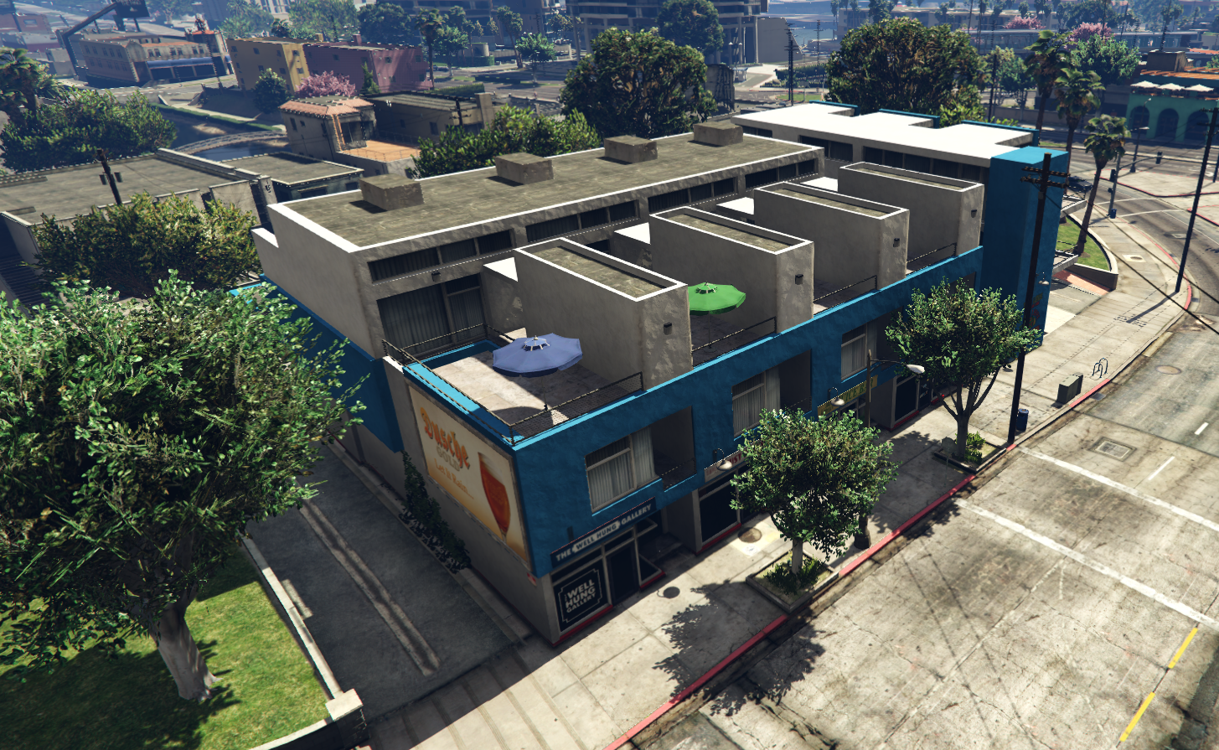

The Door
It isn’t much to look at but this is the rear and primary (only) entry to the building. Just walk up and press E to interact and follow the prompts!

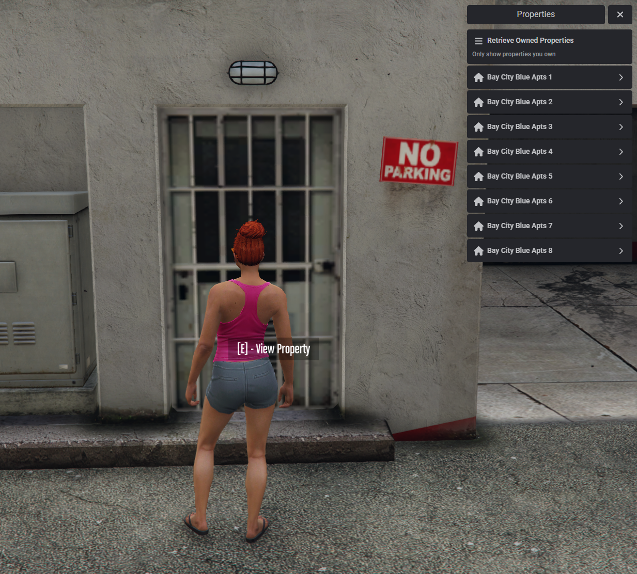

The Garage
You’ll find ample off street parking in our lot! We suggest the space to the right of the row of garages. Hit E to store or take your vehicles out.

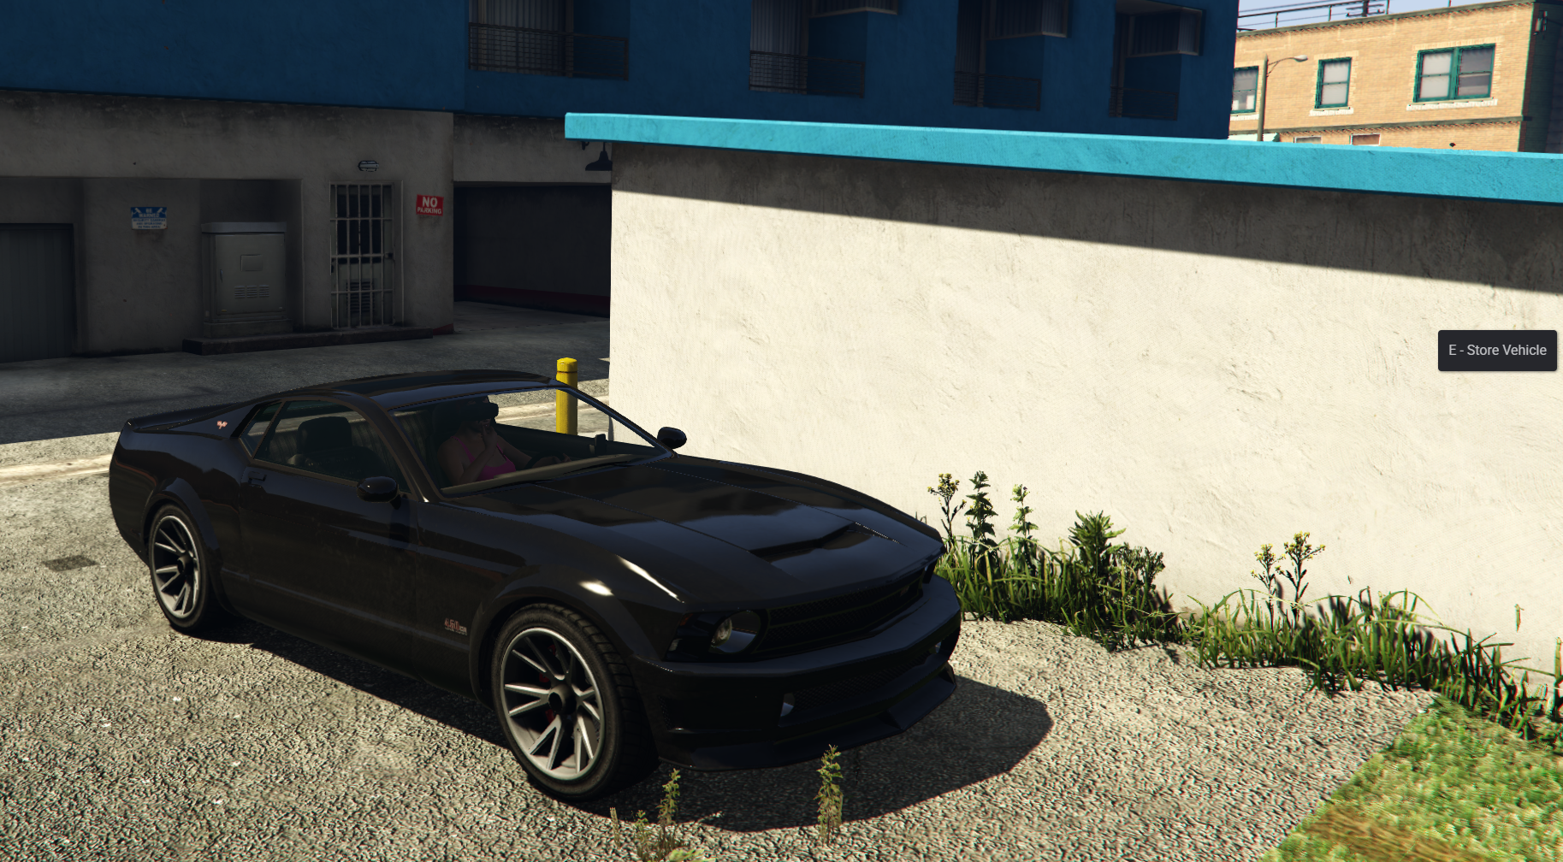

Spacious Living Space
Your new apartment features ample room to just let yourself go, or entertain!

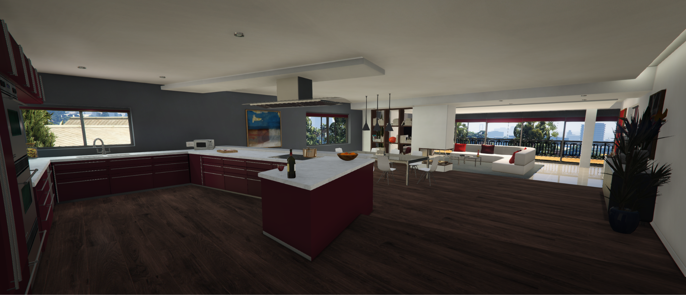

Large Closets
Each bedroom (There only 1 bedroom) features a large closet!
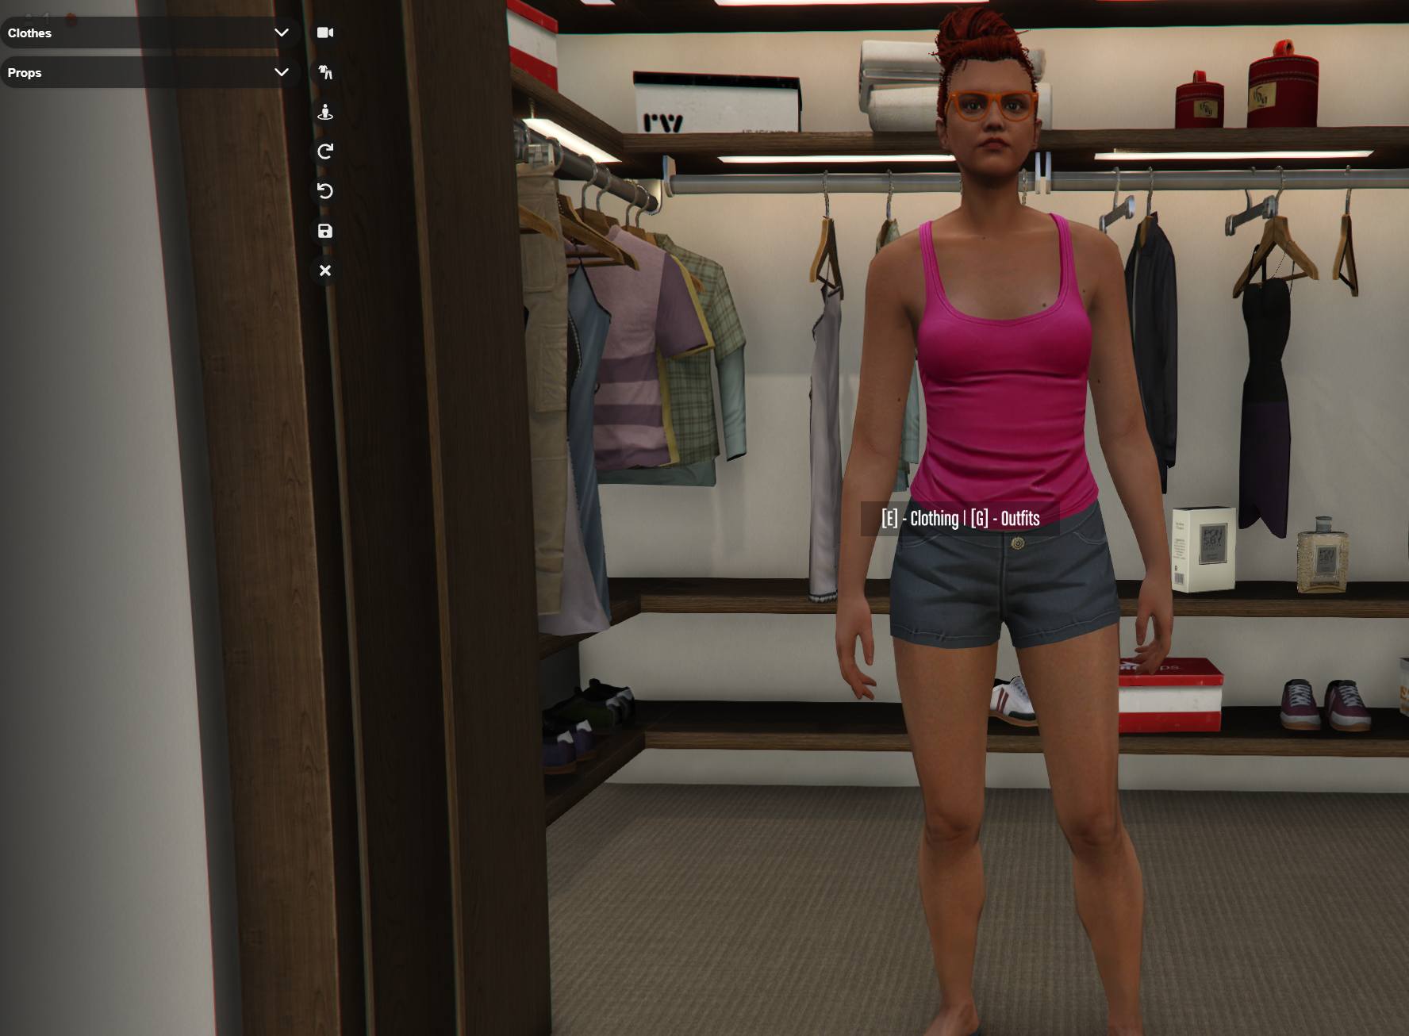

Super Secure Storage!
Each unit comes with a super secure box to store your most valuable items in!

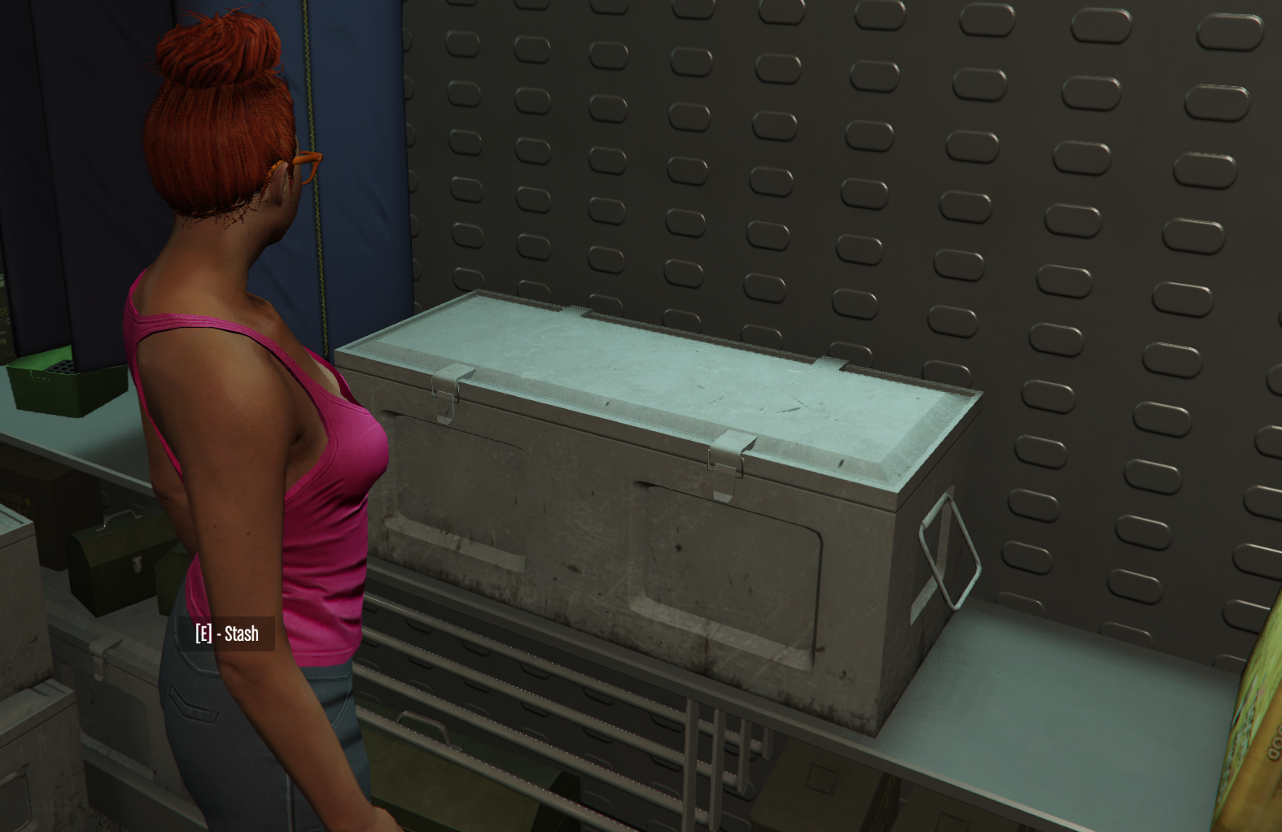

Laptops
We provide residents with laptops! Don’t forget to logout!.
